[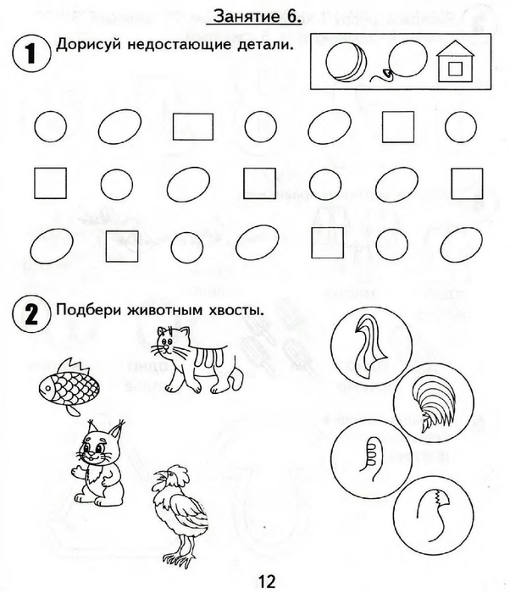](https://img0.liveinternet.ru/images/attach/c/7/94/296/94296008_large_0013.jpg) 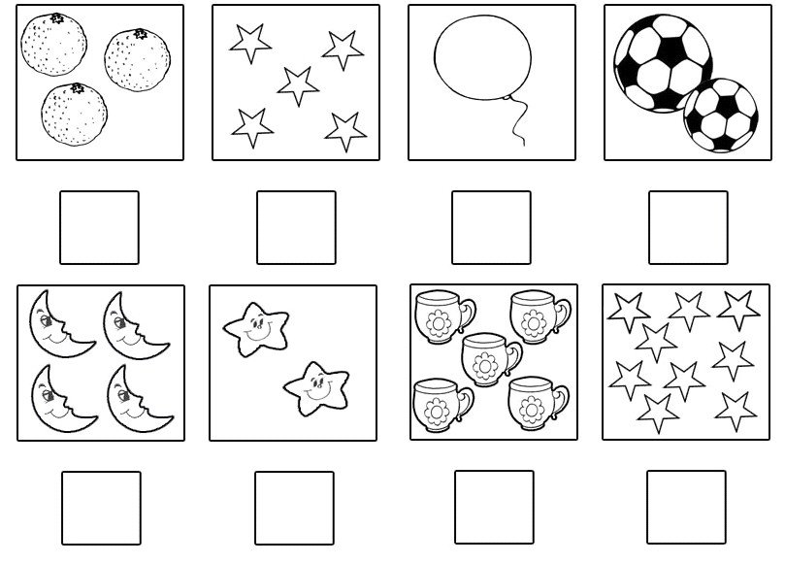[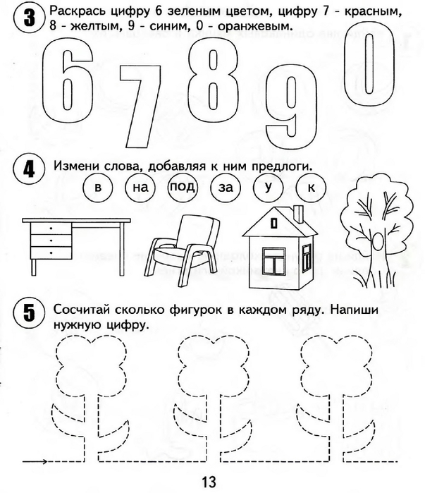](https://img1.liveinternet.ru/images/attach/c/7/94/296/94296009_large_0014.jpg)